Ch
Introduction
Solar car racing is a form of racing that has been around for several years. It not only provides a means of competition for student solar car clubs; it also provides valuable information on the use of alternative energy sources. Increasing prices of oil should be a indicator to us all that one-day, our natural gas and oil reserves will be depleted. Yearly, schools from around the country converge and compete head to head for prizes and bragging rights. Similar to many universities the FAMU-FSU College of Engineering (COE) has established a solar car club. For the 2001 solar car challenge the club has decided to build a new car named Sunsation II.
The cars in the race come in all shapes and sizes. The race specification of the solar challenge is made available to each school, and the remaining design decisions are up to the students. In spite of this, every car has solar panels, a chassis, suspension, batteries (to store the energy harnessed from the sun), wheels, and braking/steering systems.
As stated above, for the 2001 solar challenge the FAMU-FSU COE is building a new car, Sunsation II. Our team of mechanical engineers was asked to design the front suspension of this new car. Because of the complexities of this project it has been divided into two phases. The first stage of our design includes the following: Determine shock/spring configuration, determine steering mechanism and characteristics, analyze design for loading and conformance to specs, write preliminary design report, drawings completed, and have parts on hand or on order by 12/1/00. The second phase of this project includes assembling, analyzing performance, and analyzing composite material.
The purpose of this report is to explain the process used to complete the first stage of our design. It includes, design statement, background information, design specification, scheduling, budget, conceptual designs, semester overview, conclusion, and appendices.

Design Statement/Specifications
The purpose of this project is to design and build a new front-suspension for Sunsation II. The first step our team did was to investigate the prior design and analyze the pros/cons of this design.
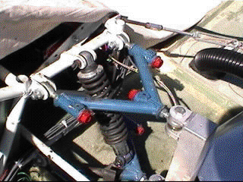

Figure 1: double A-arm independent suspension, with a coil-over shock

Figure1 shows a double A-arm independent suspension, with a coil-over shock. Once the main operations of this design was understood our team discussed the likes and dislikes with our team sponsor. A composite list of the likes and dislikes can be found below.

Prior design likes
- camber adjustment
- caster adjustment
- toe/in toe out
- simplistic yet effective design

Prior design dislikes
- weight
- bulky coil over shock
- difficult to adjust
- wheel scrub

Figure 1 also shows that the front and rear suspensions are attached to a chormoly tube chassis. Similar to any racecar design weight is always an issue. Due to the fact Sunsation II is a solar car the less amount of weight equals improved acceleration, top speed, and energy efficiency. To make the new car lighter it will utilize a composite uni-body design. Although this is excellent for subtracting a great deal of weight from the car, it is difficult to attach the suspension to the chassis. Hence, a new suspension mounting scheme must be designed to absorb the disturbance of the road. In spite of the weight reduction the composite body will give. There is still a substantial amount of weight the suspension must be able to support. Therefore, not only must the new suspension be light, it must be also be sturdy enough to support the 900 to 1000 lbs. of load.
For aerodynamics purposes, the car will be totally enclosed by the uni-body, with only the wheels visible. The suspension must operate inside this shell with out colliding with the uni-body, or effecting the driver. The prior design had a total suspension design of 6” (3” up 3” down). It was stated by the design team of Sunsation I that this amount worked well. Therefore our team decided to design the new suspension to this specification.
The design specifications for Sunsation II includes easy adjustment for camber, caster, toe-in/out, unibody mountable, 6” of total suspension travel, light weight, and support body weight (900 to 1000lbs).

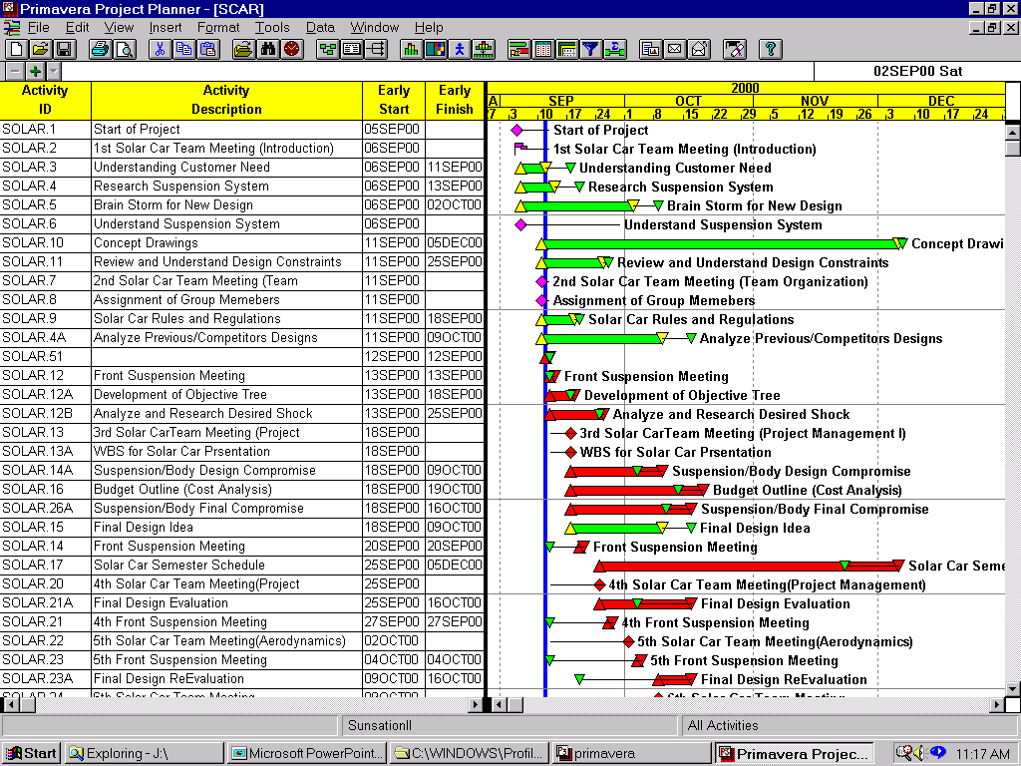Schedule

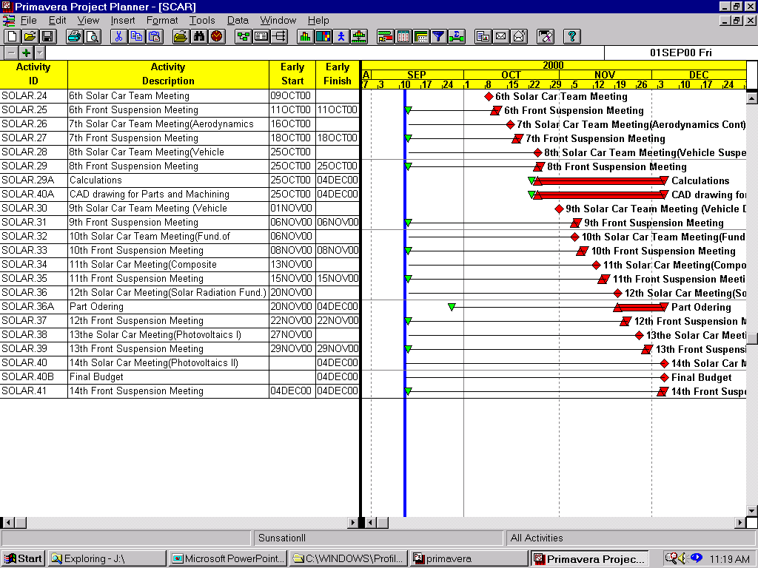

Figure 2: schedule of the project, created using primavera

Figure 2 includes the schedule of the project, created using primavera. Some of the main points included are the weekly solar team and front suspension team meetings. The solar team meetings provided a chance for all the groups to report progress. There were also weekly lectures by professors. The topics covered were suspension design, material selection, scheduling, and aerodynamics. The weekly meetings for the front suspension team were used to brainstorm concepts, and solve problems. Several of these meetings were with the SAE team, which provided valuable information concerning shock selection and suspension geometry. The tasks completed from the schedule include:
- WBS
- Budget
- Final Design
- Shock selection
- Suspension mounting system
- Simulated Drawings
- Minimizing Scrub
Unfinished tasks include:
- Composite material stress analysis
- Finalized engineering drawings
- Ordering Parts
- Machining parts
- Suspension performance analysis
The second phase of the design will start next semester, the Unfinished tasks and next semester task will be added to Figure 2.

Budget
- Bulk metal (aluminum/iron) 600.00
- Shocks 1200.00
- Wheels 1200.00
- Tires 1000.00
- Hardware (Bolts/Nuts) 300.00
- Steering linkage 500.00
- Steering Box 500.00
- Brake calipers 400.00
- Brake rotors 700.00
- Rotor hubs 800.00
- Brake lines 200.00
- Master cylinder 200.00
- Pedal Assembly 250.00

- Total 7850.00

The money used to construct Sunsation II is coming from donations made by small companies and several large corporations. The purpose of this budget is to provide an estimate of the total cost of the front suspension. The prices are inflated slightly in order to make sure that the amount given will cover the design and construction of the suspension. The parts included on the budget are the essential components of the front suspensions. The front suspension group realizes that there maybe components not included on this budget/parts list hence the inflated prices, which allows the adding of parts without going over budget.

assis Layout

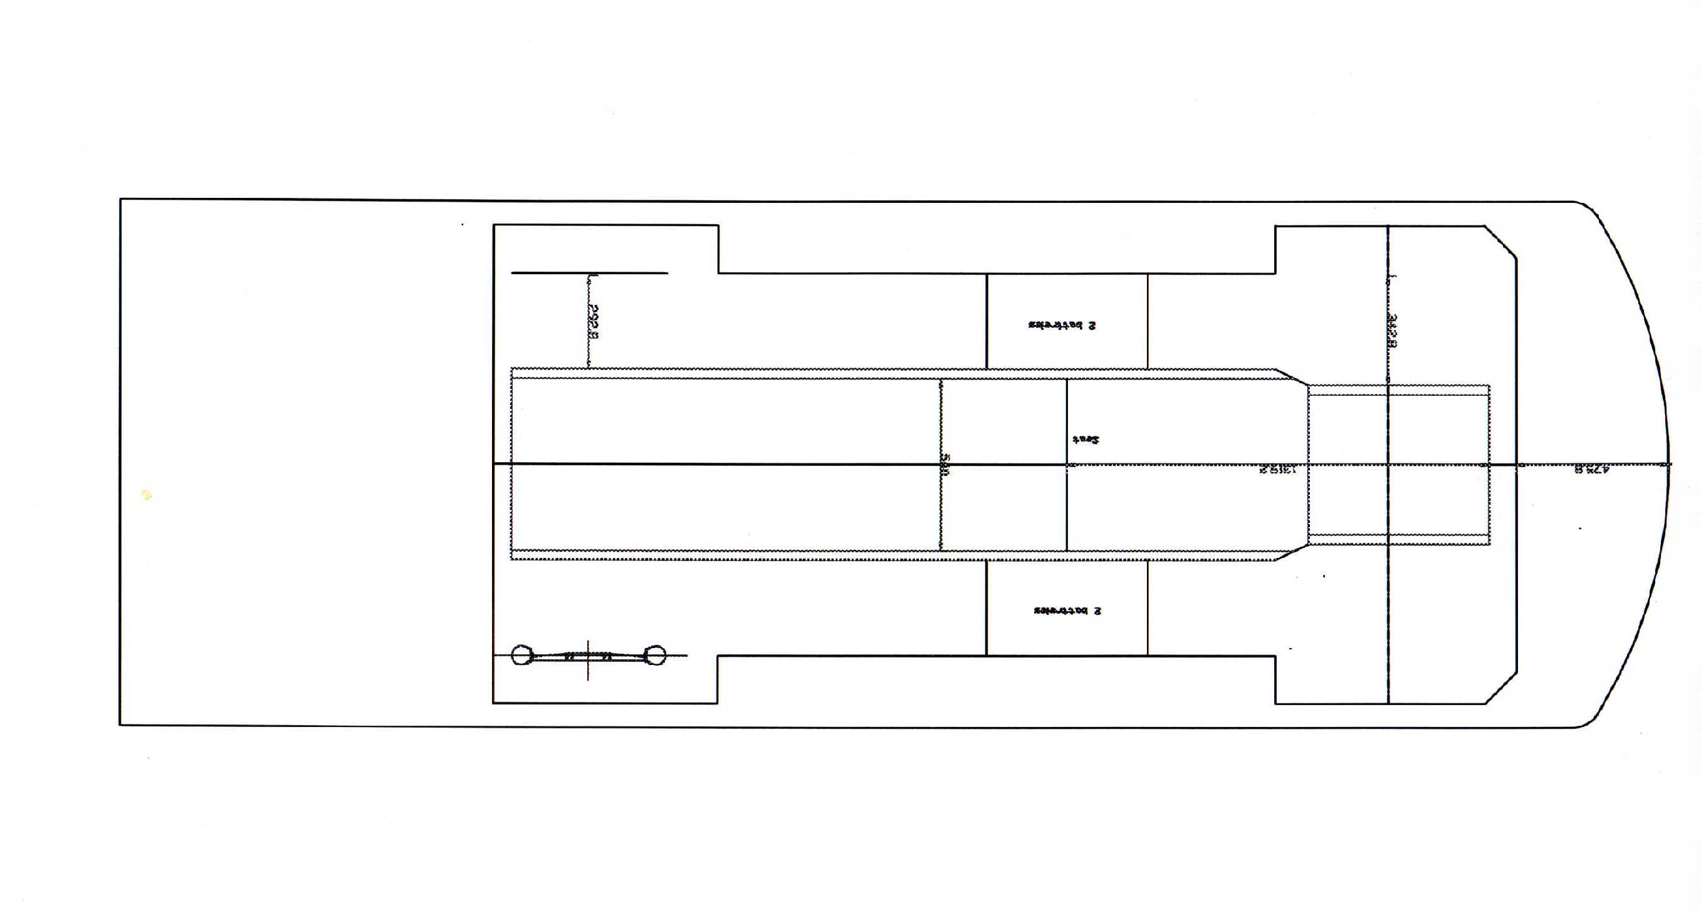
Figure 3: Top view of the newly designed solar car (SunsationII)

With the need for a new solar powered car, there was a great desire for a total newly designed solar car body (SunsationII). The first task was to design a new body that was lighter, sleeker, and more aerodynamic. There was a lot of brainstorming and analyzing of on how to obtain this new body. Although the final design of the body was just recently completed, the overall idea on how the body would actually look was decided at an earlier date. Figure 3 shows the actual top view of this newly designed solar car body. A clearer picture of this view can be seen in the appendix A.
The next task entailed designing a new suspension and incorporating it into the new body layout for the solar car. As can be seen above in Figure 3 (appendix A1), the front section of the car was the specified design area for the new front suspension. A closer view of the design area can be viewed in Figure 4. Figure 4 (appendix A2) shows the design area along with preliminary dimensions (in mm and in).

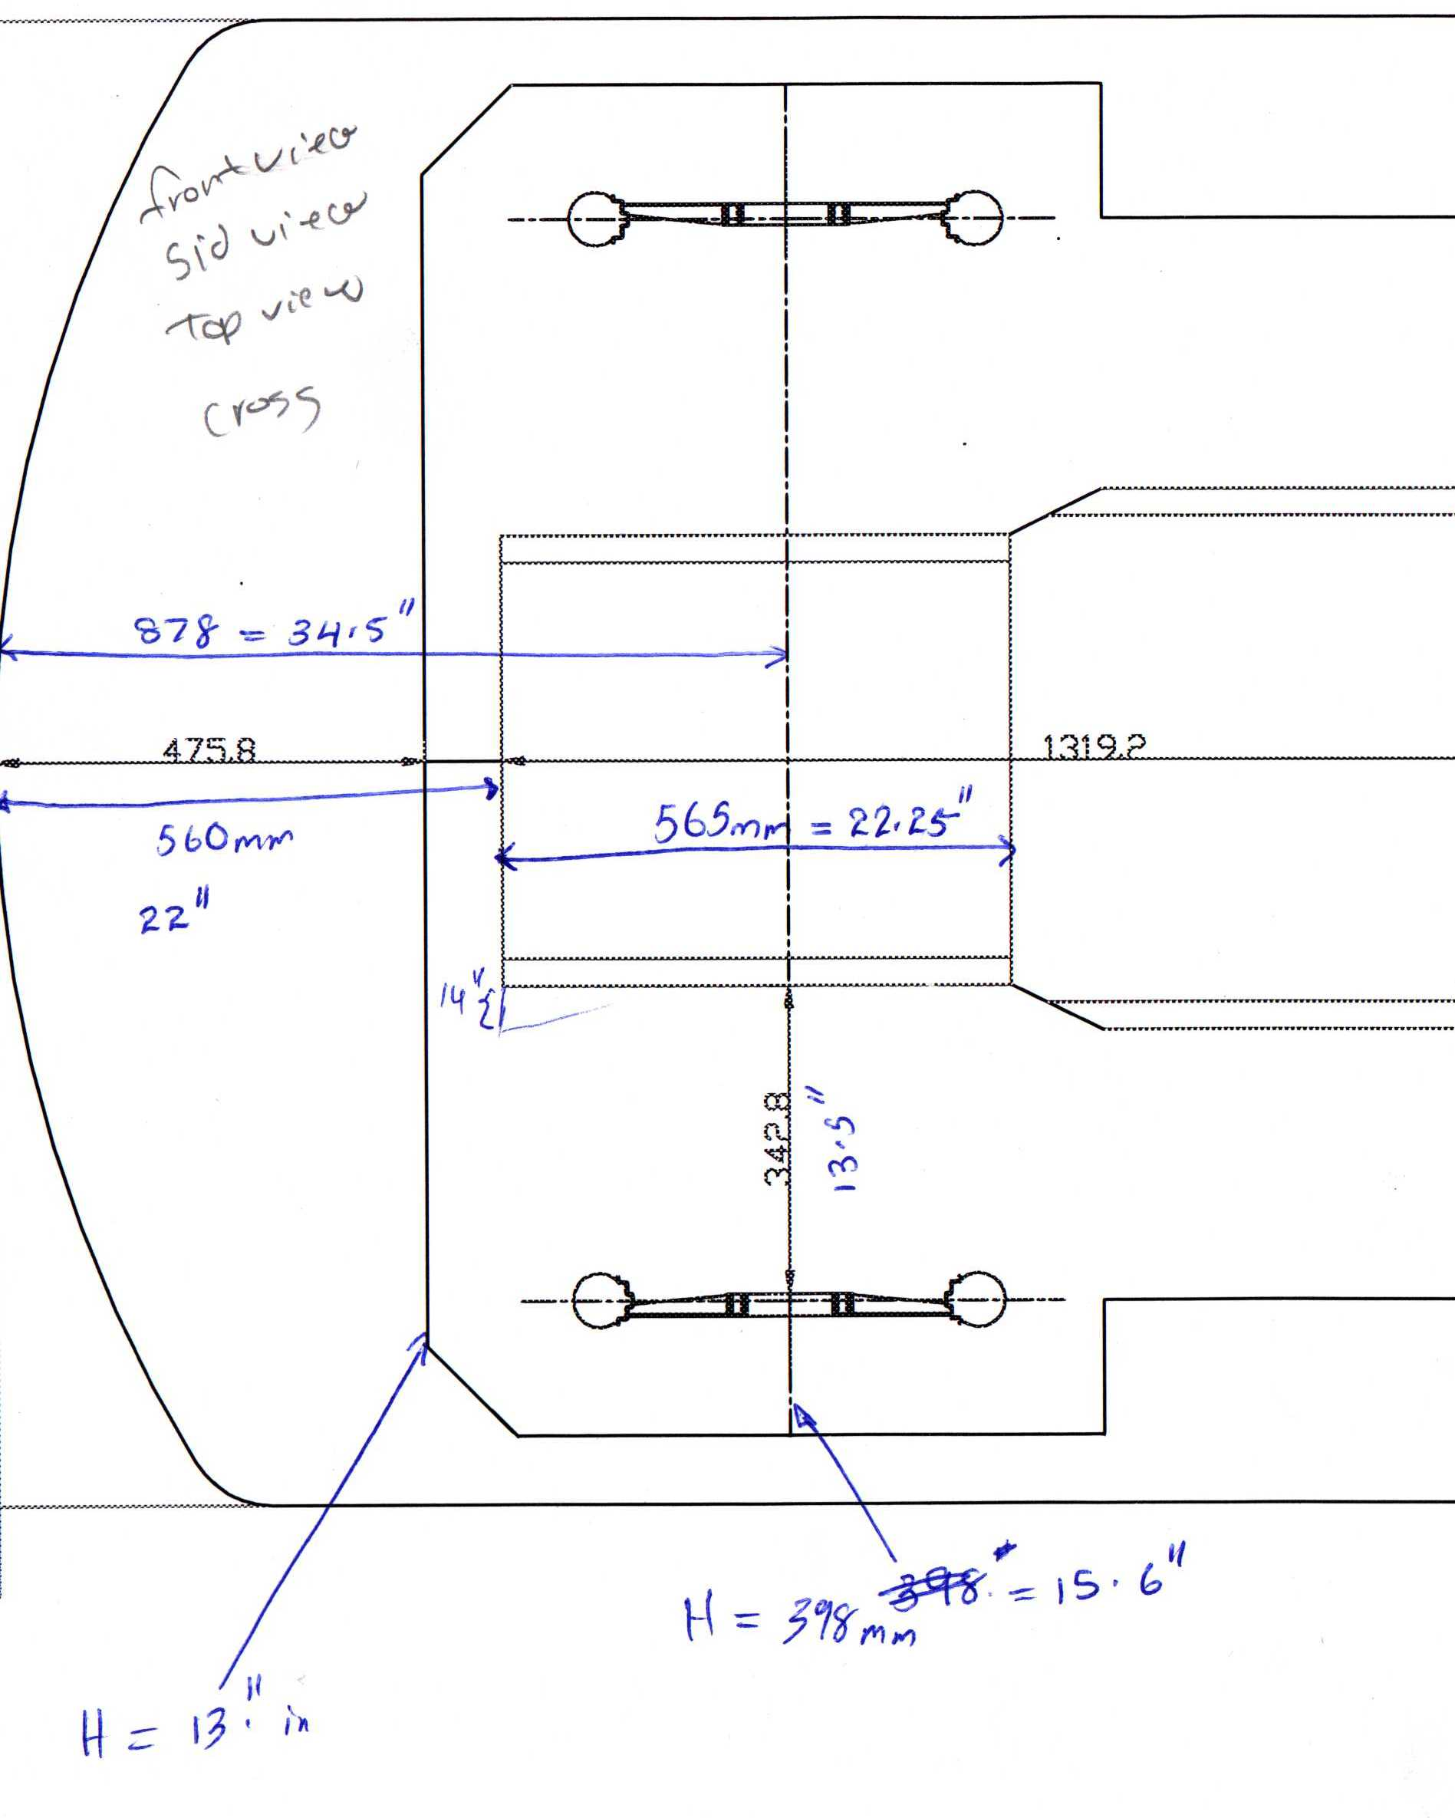

Figure 4: Top view illustrating the front-end of the newly designed solar car (SunsationII).

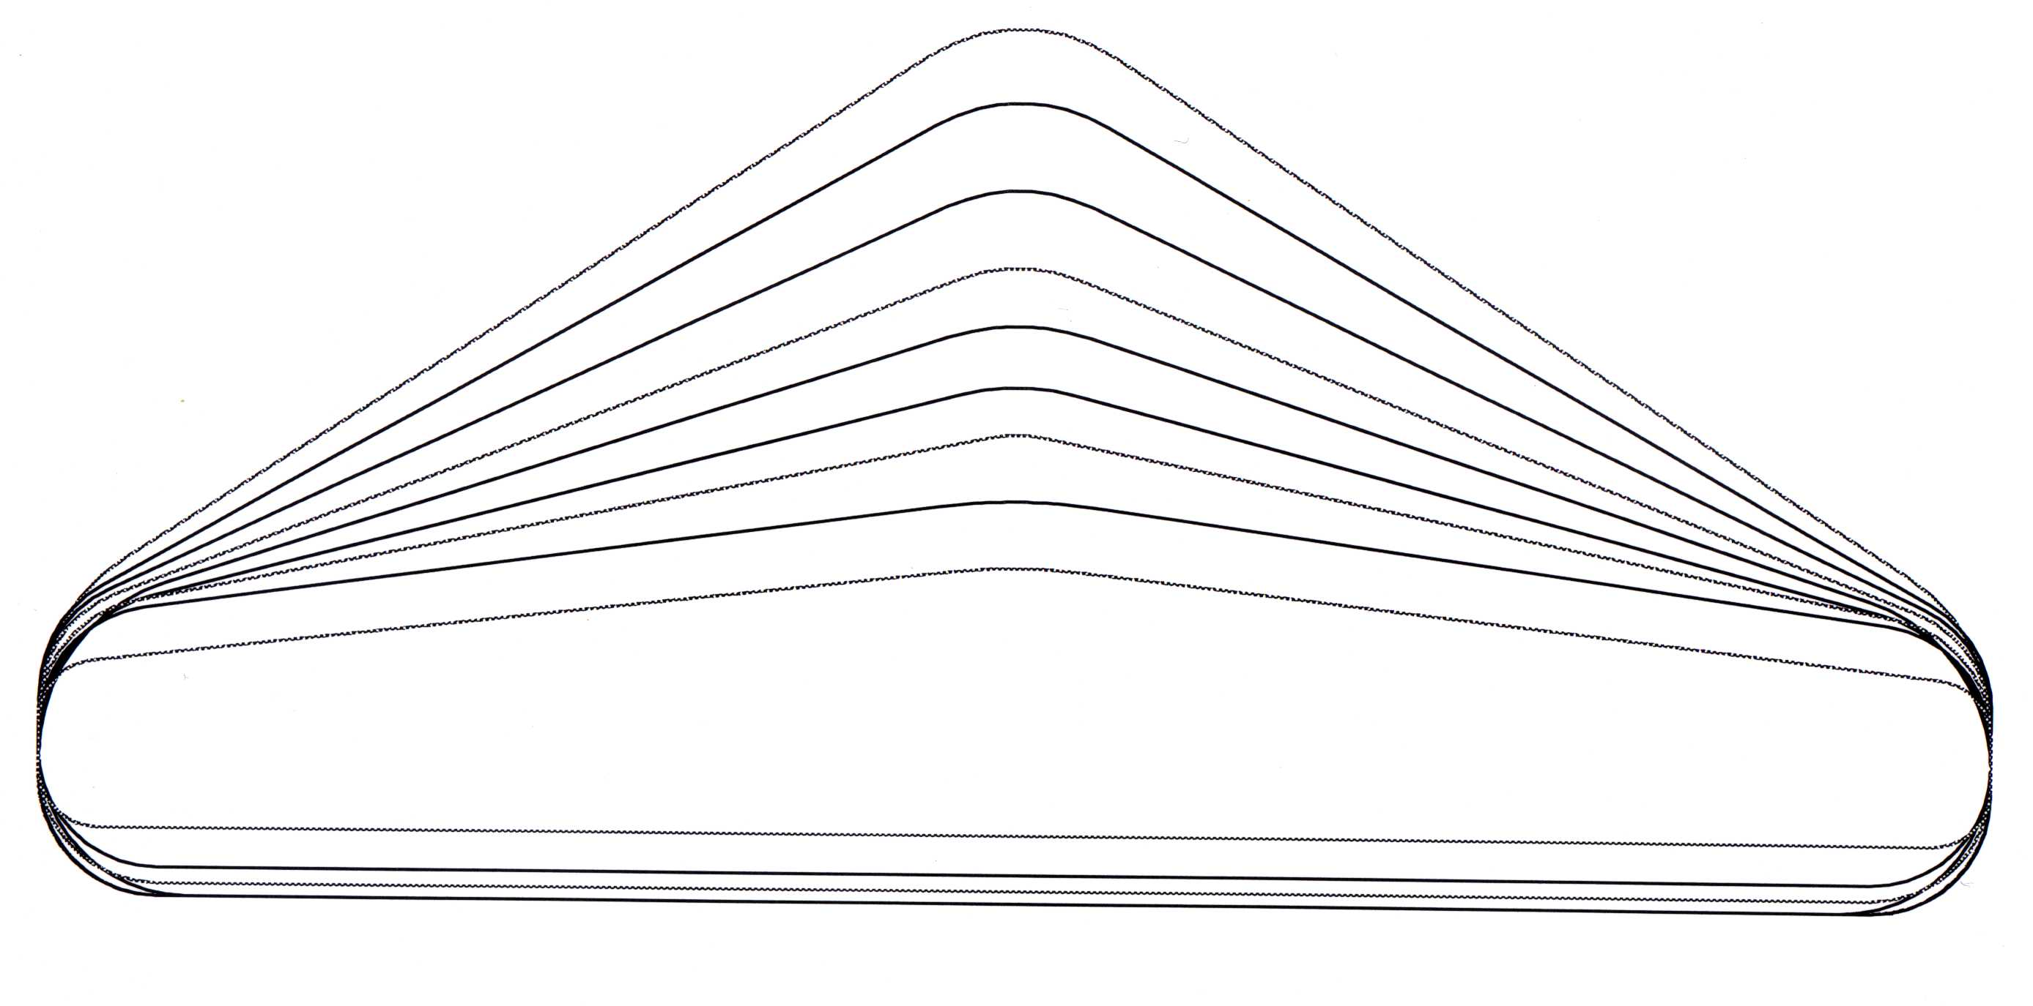
Approximately 15.6
Figure 5: Front cross-section view of newly designed solar car (SunsationII)

Figure 5 (appendix A3) shows the actual front cross sectional view of the car, from the front (tip) to the rear of car. As seen above, the cross sectional clearance where our front suspension design can and will fit is approximately 15.6”. Initially, the first cross section dimensions were a problem for our design, due to limited travel area for the suspension to travel up and down. However, the area layout for the solar cells was redesigned because they were not flexible enough to accommodate too much exponential slope of the body. The body design was changed from a curved shape to a linear shape. With this change, we were able to incorporate our new suspension in the new cross-section area.

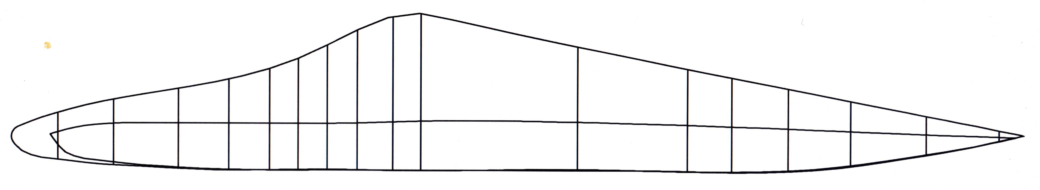
Figure 6: Side view of newly designed solar car (SunsationII)

Figure 6 (appendix A4) shows the side view of the new design. The vertical lines in the drawing illustrate the actual cross section areas seen in Figure 5. These cross sections are incorporated not only for the sectional dimension areas needed to help all the groups in their design, but also for a layout of structural design to support the honeycomb unibody design.

Shock
The shocks on the previous design were functional, but were extremely heavy and proved to not be fully adjustable. In order to save weight, improve performance, and be fully adjustable, we decided to implement motorcycle shocks fitting all the desirable specifications. These shocks are made by “Fox Racing Shocks”, and have and 1.5” of travel, interchangeable springs to adjust for pre-load, and high performance. This idea of going with a motorcycle shock was given by our sponsor Dr. Harrison as well as some of our fellow colleagues on the SAE team. This type of shock has also been used in some of our competitors (other schools) cars. Essentially, our design was designed around the new body design and the desire for this lightweight, smaller and more efficient shock. Figure 7 (appendix C1) shows a schematic drawing of the desired “Fox Shox” that will be used in our design.
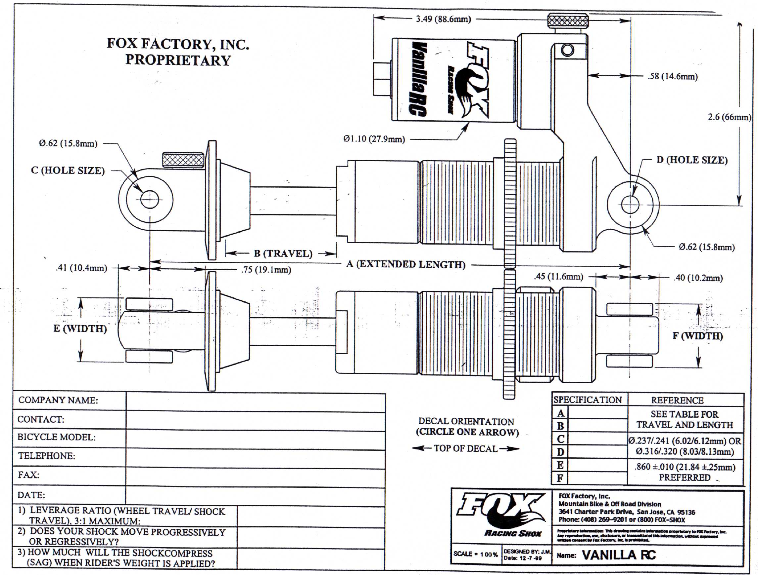
Figure 7: Schematic drawing of Fox Shox.

Conceptual Designs
First Design Concept
One of our main specifications was to obtain at least 6 in. of travel in the vertical direction. To attain this, we decided to use rocker arm and control arms in our. This initial idea consisted of a double A-arm independent suspension. This design would consist of a rocker on the shock and arm, which would enable us to achieve the desired travel of 6 inches from the short travel of 1.5 in on the shock, 3” in both y and the –y direction. The max width of the car is 1.65 cm, so in order to get 6 inches of travel from the suspension the shocks are mounted inside of the chassis. From the shock and rocker a tie rod is used to translate the vertical displacement from the wheel hub to the shock. This tie rod can also be use to adjust the ride height of the car along with the adjustable shock. One main design includes A-arms constructed of the same threaded rod used in the damper rod. This design was used in the SAE car with excellent performance.
Initially this design appeared that it would work and would be very efficient. However it would not be deemed acceptable due to area constraints that may compromise the main body design and question of efficiency with cycling of the suspension. This concept can be seen in Figure 8 (appendix B1) to give a visional feel for the design.

Second design concept
With this design, we would still be able to obtain the design specifications, like that of the first design. 6in of travel, lightweight, adjustable for camber, caster, toe in/out, and reduce scrub. However with this new design no rocker arm or tie rod was needed to obtain our desired specifications. This design would incorporate the shock directly mounted on the double A-arm suspension. The shock would be mounted about 2in off of the composite body directly to the bottom A-arm and rigidly connected to the composite body. A 2D drawing of this design can be seen below in figure 9.
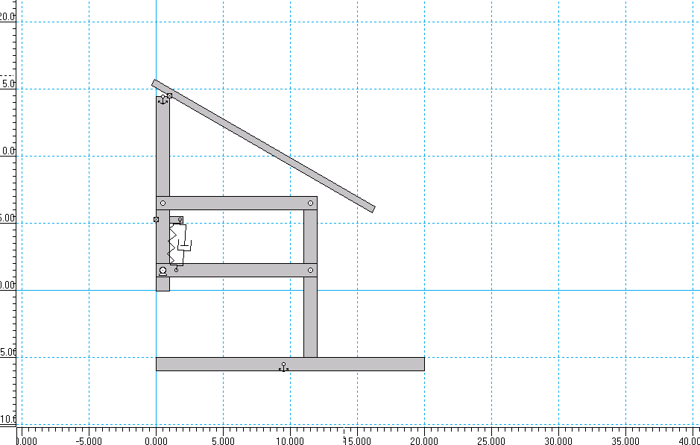
Figure 9: 2D drawing of second concept design of suspension.

Now in order to obtain the 6 in. of travel with a shock that only has 1.5 in travel, we had to calculate how long the A-arms would be and also how much separation between the A-arms were needed achieve the travel high and still have maximum shock efficiency. Through some minor geometric calculations we were able get the approximate arm length and distance between them. This can be seen in Figure 10 (appendix B). With this design, we still had to deal with the problem of travel clearance for the suspension. This secondary design was determined to be well thought-out and producible but still needed some fine-tuning to obtain and maximize the travel clearance.
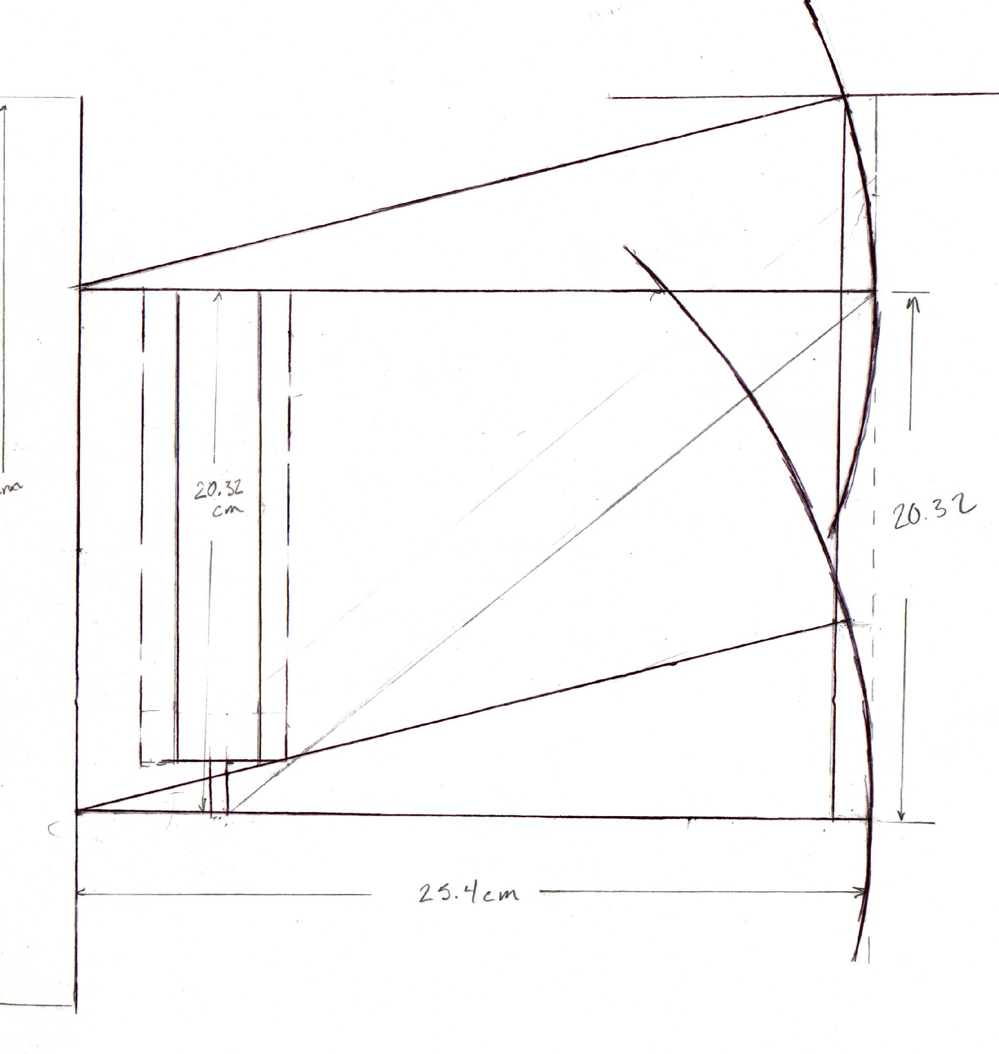
Approximately 16 degrees
1in scrub
Figure 10: Geometric sketch for concept 2, of how distances, lengths, and angles were determined.

Final design concept
After some long and stressful brain storming, a final idea arose on how to deal with the travel clearance for the system. This idea, which was just a trial assumption, was analyzed and confirmed through some research done by one of our professors, Dr. Hollis. This trial idea not only solved our clearance problem but also simultaneously decreased our scrub problem (about .5in decrease) associated with our tires and the travel displacement of the suspension system (moving up and down). This new design consisted of shortening our upper A-arm and implementing a slight angle at the top of connection arm (wheel assembly to suspension system). Figure 11 will give you a better view of how our secondary concept was redesigned to achieve our primary specifications for the front suspension.
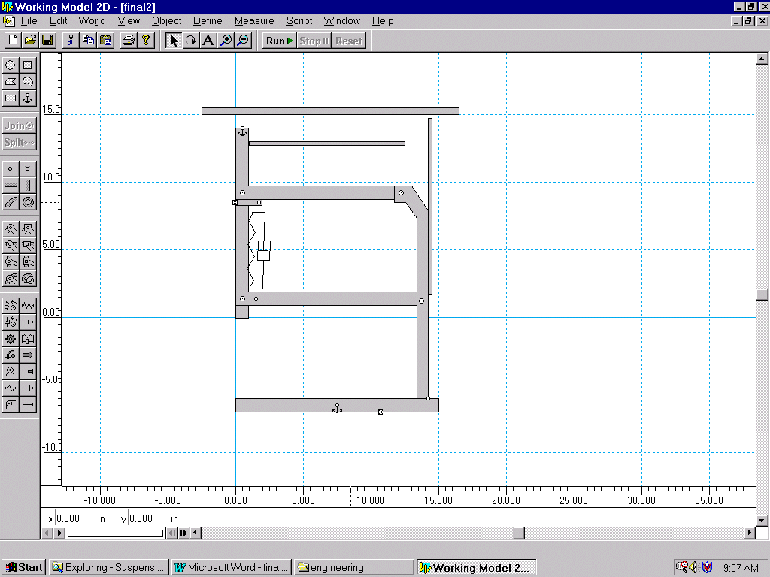Figure 11: 2D drawing of final design concept of suspension.
With our final design concept, we also had to obtain the 6in of travel with a shock that only has 1.5in travel. We performed the same minor geometric calculations on how long the A-arms would be and also how much separation between the A-arms were needed achieve the travel high and still have maximum shock efficiency. This can be seen in figure 12 (appendix B).
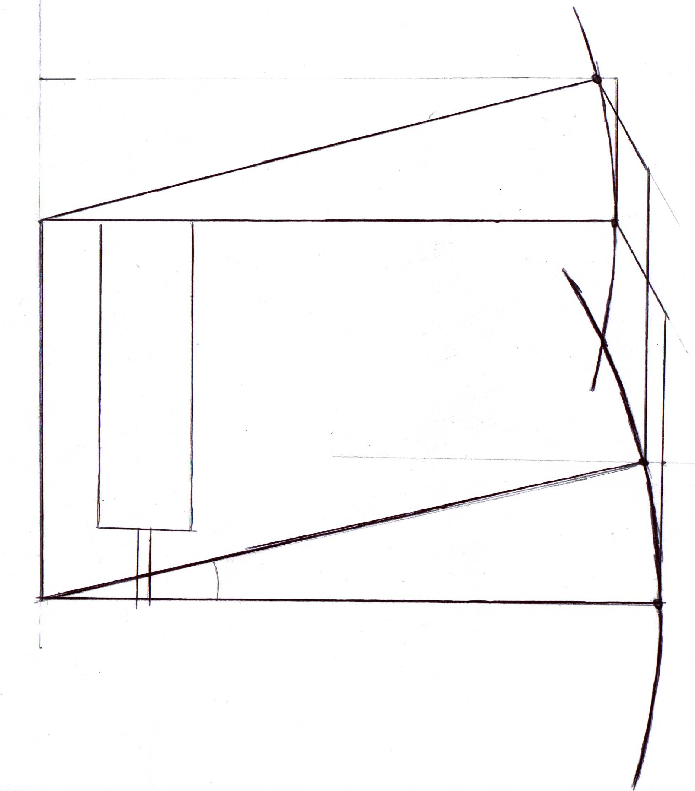
.5in scrub
Approximately 13.5
12in
11in
9in

Figure 12: Geometric sketch of final design; distances, lengths, and angles.
Our next task after coming up with our final design, was to determine how we would mount the suspension system on to this newly designed honeycomb composite body. After some analysis, it was determined that four plates would be needed to mount the suspension on to the body. These four plates were the pivot points for the suspension system. However, it was further analyzed that a fully connect bulkhead would be needed to increase durability strength for the system. After this was done, mechanical drawing of all the major parts was sketch out and drawn use the ProE software. A sample drawing of the bulkhead can be seen in figure 11 below. Also, a subassembly drawing of the system can be view in appendix C. All other engineering drawings of the different parts can be viewed in appendix C.
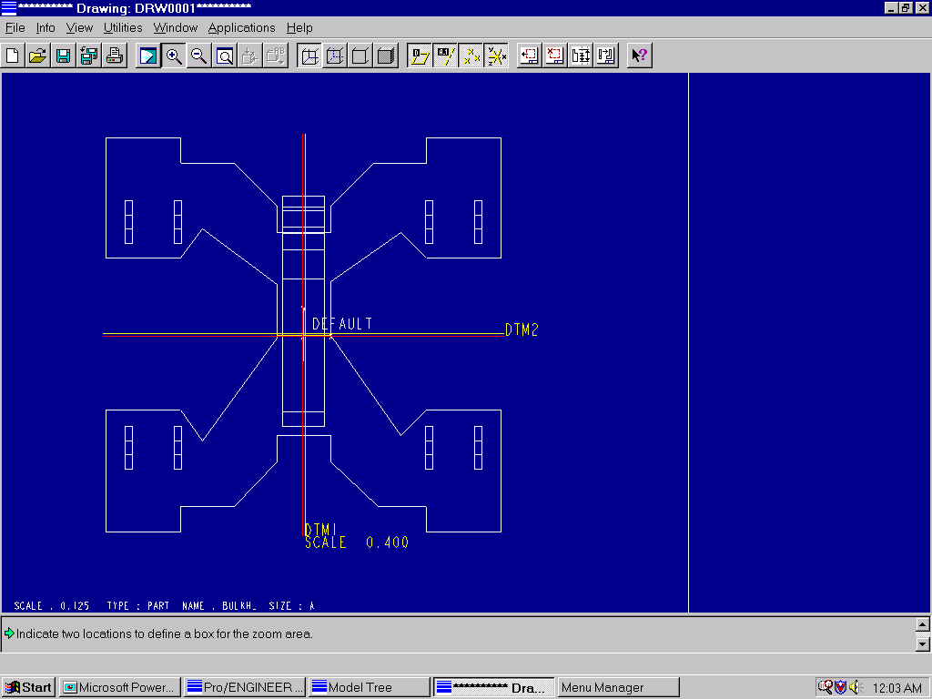

Figure 13: ProE drawing of bulkhead.
Conclusion
In conclusion we have completed most of our goals that were set at the start of the project. After analyzing and understand the costumer’s problem, we needed to come up with a compropable new design for the front suspension for the new solar car (Sunsation II). After a long and stressfully period, we can say that we’ve learned alot about the process of coming up with a new design. Starting with analyzing the problem, and understanding the desired specifications. Then researching the suspension system and brain storming ideas for a new and innovative design. Developing a work Breakdown Stucture came after, which enabled us to develop a project schedule. Although the project is behind were able to come up with a new design, perfom some calculations and draw up some initial engineering drawings. For next semseter we hope to redevelop our WBS and schedule in order to stay on task and accomplish the main goal, which is to build a front suspension with all the desired specification and incorporate it into our new solar car (Sunsation II).

